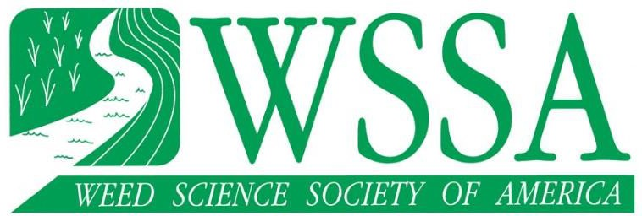

WSSA Standing Committee Report
Committee Name and Code: W3g
Committee Chair: Nicholas T. Basinger – S- Rotating off 2026

Committee Members (includes sub-committee members):
Committee composition can be found at (WSSA Committee Roster).

Stephen Meyers – NC – Rotating off 2027
Annu Kumari – NE – Rotating off 2027
Matthew Wiggins - NC/S – Rotating off 2026
Sandeep Rana – NE – Rotating off 2026
Tommy Butts – NC – Rotating off 2028

Board of Directors Liaison: Olivia Landau

Committee members rotating off and recommended replacements:
Mandy Bish – Rotated off due to other conflicts – Replaced by Tommy Butts
Misha Manacheri – S – Rotating off 2024 – Replaced by Annu Kumari

Summary of past year’s activities including:
- Committee goals – Receive high quality packets for WSSA graduate students and select an outstanding student for the OGS Award.
- Committee accomplishments

  - For the 2025 award we received 8 student packets. We utilized a general rubric for committee members to separate students based on their packets. All committee members provided their ranks for each student packet and ranks were tallied with the lowest rank (1) representing the award winner. This year for 2025 Navdeep Godara (Advisor Shawn Askew) from Virginia Tech was selected as the award recipient.

- WSSA funds requested if any? None.
- Current state of the committee’s projects or activities? Ongoing each year selecting students each fall.

- Any new information posted on the WSSA website? None.
Summary of plans for next year (changes in goals, key initiatives, plan of action, etc.): Continue to solicit high-quality packets from the WSSA. No new changes are planned for next year. The rubric has been helpful as a guide for the committee. The rubric is not binding by the committee member but is helpful in separating very competitive packets.

Recommendations for Board or Membership action (funds¹ or other requests):
- Make sure that the date on the website matches that of the one on the sheet for the award. There was some confusion this year since the dates didn’t match.

¹If requesting funds, please fill out the WSSA Project Proposal Form and submit at the same time as the WSSA Committee Report.

