WSSA Presidents

1954-56 R.H. Beatty* -deceased 1-1-67

1956-57 W.B. Ennis-deceased-8-11-2000

1958-59 A.S. Crafts-deceased-2-9-90

1960-61 K.P. Buchholtz-deceased-4-22-69

1962-63 W.C. Shaw-deceased-5-87

1964-65 G.Fred Warren-deceased-7-18-99

1966-67 William Furtick-deceased-5-16-07

1967-68 Richard Behrens-deceased-11-11-012

1968-69 Boysie Day-deceased-6-5-88

1969-70 G.C. Klingman-deceased-7-27-98

1970-71 L Danielson-deceased-2-98

1971-72 Dayton L. Klingman—deceased-11-3-05

1972-73 Robert P. Upchurch
351 Shetland Valley Ct
Chesterfield, MO 63005-4840
(636) 530-6022
phil@upchurchstory.com

1973-74 Earl Rodgers –deceased-5-5-04

1974-75 Ellery Knake-deceased-3-1-09

1975-76 Charles R. Swanson
3035 Terrace Drive
Las Cruces, NM 88011

1976-77 Fred W. Slife-deceased-5-8-02

1977-78 Chester Larry Foy
50 Revolution Circle
Christiansburg, VA 24703
(540) 382-4830
clfoy@shentel.net

1978-79 Paul W Santelmann
5505 W. 19th Ave., Apt.101
Stillwater, OK 74074
(405) 372-0564
pwtelmann@juno.com

1979-80 J.R. Hay
238 Christopher Crescent
Saskatoon, SK S7J 3R6
Canada
(306) 373-0922
dar.birder@gmail.com

1980-81 Will D. Carpenter
456 Conway Meadows Drive
Chesterfield, MO 63017-9625
(314) 469-0385
will.carpenter@sbcglobal.net

1981-82 Don E. Davis deceased-2-21-07

1982-83 T.J. Sheets-deceased 7-6-013

1983-84 C.G. McWhorter – deceased-6-17-03

1984-85 John Nalewaja
1110 3rd Ave. N #402
Fargo, ND 58102
(701) 231-7735
john.nalewaja@ndsu.edu

1985-86 James D Riggleman
18 Guyencourt Rd
Wilmington, DE 19807
(302) 658-0851
jimriggleman@comcast.net

1986-87 Orvin C. Burnside
1545 McClung Dr.
Arden Hills, MN 55112
(651) 636-3035
orvburns@comcast.net

1987-88 Jean H Dawson
9103 S. Moore Rd
Prosser, WA 99350
(509) 786-3956
JeanandConnie@gmail.com

1988-89 John F Ahrens-deceased-11-10-012

1989-90 Homer M LeBaron-deceased-6-12-012

1990-91 Larry W. Mitch-deceased-8-16-2000

1991-92 John R Abernathy
4805 95th St.
Lubbock, TX 79424
(806) 794-3438
cinjona2@sbcglobal.net

1992-93 Joe Antognini
704 Central Ave., Apt 223
Summerville, SC 29483
(843) 873-8264

1993-94 Harold D. Coble
202 Frostwood Drive
Cary, NC 27518
(919) 851-1775
Harold.coble@earthlink.net

1994-95 Alex G Ogg, Jr
PO Box 53
Ten Sleep, WY 82442
(307) 366-2444
ogga@tctwest.net

1995-96 Jim L Barrentine
1519 N Starr Dr
Fayetteville, AR 72701
(479) 587-0545
James.barrentine@cheminova.com

1996-97 Stephen O. Duke
USDA-ARS Natural Products Center
PO Box 8048
University, MS 38677
(662) 915-1036
sduke@olemiss.edu

1997-98 Calvin G Messersmith
288 Prairiewood Dr. S
Fargo, ND 58105-5051
(701) 237-3751
cal.messersmith@ndsu.edu

1998-99 F. Dan Hess-deceased-8-4-2000

1999-2000 James ‘Mike’ Chandler
1324 Tidwell Lane
Celina, TX 75009
(469) 202-2001
jm-chandler@tamu.edu

2000-01 Lawrence R. (Dick) Oliver
18964 Melanie Rd
Springdale, AR 72764
(479)751-3905
trinaoliver@cox.net

2001-02 Charlotte Eberlein
University of Idaho
Twin Falls R&E Center PO Box 1827
Twin Falls, ID 83303-1827
(208) 736-3600
ceberl@uidaho.edu

2002-03 Bradley A Majek
Rutgers Agric. Res. & Ext. Center
121 Northville Rd
Bridgeton, NJ 08302-5919
(856) 455-3100 ext 4122
majek@aesop.rutgers.edu

2003-04 Allan S Hamill
2643 County Road 20 RR#1
Harrow, ON NOR 1G0
CANADA
(519) 738-6932
alhamill70@gmail.com

2004-05 Donald C Thill
University of Idaho

AG SCI. 242
Moscow, ID 83844-0000
(208) 885-6214
dthill@uidaho.edu

2005-06 Carol Mallory Smith
Crop & Soil Science
Oregon State University
107 Crop Science Bldg
Corvallis, OR 97331-3002
(541) 737-5883
Carol.Mallory- Smith@oregonstate.edu

2006-07 Dale Shaner
4815 Stonehaven Drive
Ft. Collins, CO 80525
(970) 556-826
daleshaner@aol.com

2007-08 Jill Schroeder
Dept. of Entom., Pl. Path., & Weed Sci.
New Mexico State Univ.
Box 30003, Dept 3BE
Las Cruces, NM 88003.
(575) 646-2328
jischroe@nmsu.edu
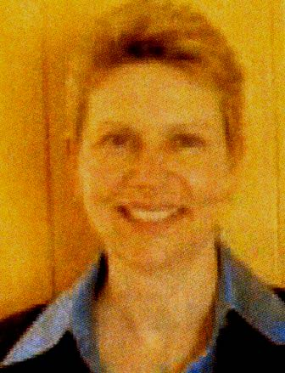

2008-09 Jeffrey Derr
Virginia Tech
Hampton Roads Ag. Res. & Ext.
Center
1444 Diamond Springs Rd
Virginia Beach, VA 23455-3363
(757) 363-3912
jderr@vt.edu
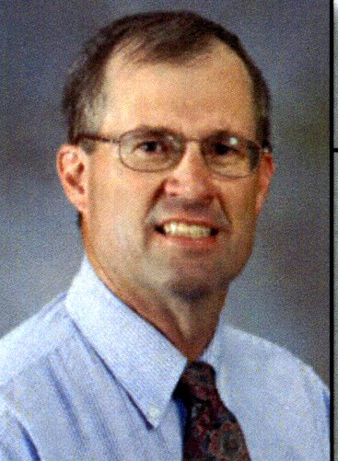

2009-10 David Shaw  Mississippi State University  Office of Research and Econ. Develop.  617 Allen Hall  Mississippi State, MS 39762  (662) 325-3570  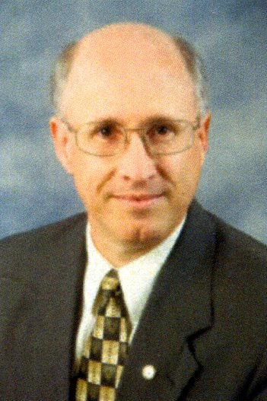  dshaw@research.msstate.edu | 2012-2013 Rod Lym  North Dakota State University  Loftsgard Hall  Fargo, ND 58108  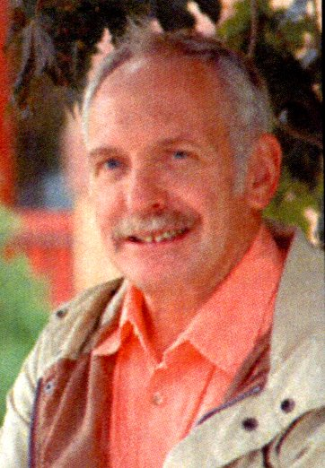  (701) 231-8996  rod.lym@ndsu.edu
2010-11 John Jachetta  985 Maxwell Lane  Zionsville, IN 46077  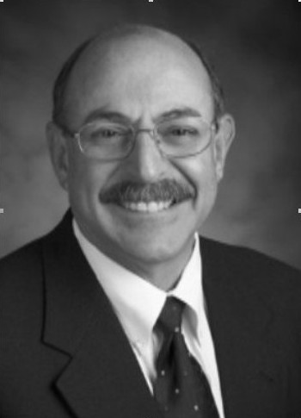  (317) 873-3668  jjjachetta@dow.com | 2013-14 James Kells  Michigan State University  Crop and Soil Sciences  East Lansing, MI 46624  (517) 355-0271  kells@msu.edu  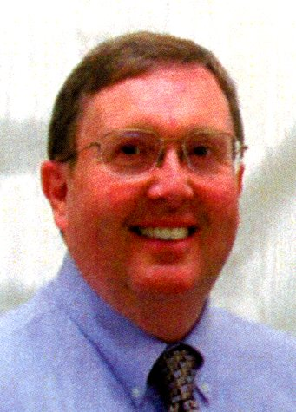
2011-12 Michael Barrett
Univ. of Kentucky
Dept. of Plant and Soil Science
1405 Veterans Drive
Lexington, KY 40546
(859) 218-0712
mbarrett@uky.edu
